

ITA14 12- ETHICAL HACKING EX - 4

Experiment 4: LS, CAT, MKDIR Commands
Aim
To execute and display the results of the following commands in Kali Linux Operating System: ls, cat, and mkdir.
Procedure
- Open Kali Linux.
- Open terminal.
mkdir command
- mkdir EH — press Enter.
- cd EH — press Enter.
- mkdir Topic1 — press Enter.
- cd Topic1 — press Enter.
- touch notes.txt — press Enter.
ls command
- ls — press Enter.
- It displays the files and directories present in the current directory.
Output:
notes.txt
Inserting content into the created file
- nano notes.txt — press Enter.
- Type the following:
Introduction to Ethical Hacking
Types of Hackers and Their Roles
Ethics of Ethical Hacking
Ethical Hacking and the Legal System
Proper and Responsible Disclosure
- Press Ctrl + O — press Enter to save.
- Press Ctrl + X to exit.
cat command
- cat notes.txt — press Enter.
- It displays the contents of the file.
Output:
Introduction to Ethical Hacking
Types of Hackers and Their Roles
Ethics of Ethical Hacking
Ethical Hacking and the Legal System
Proper and Responsible Disclosure
mkdir command verification
- mkdir Unit2 — press Enter.
- ls — press Enter.
- It displays the file and the newly created directory.
Output:
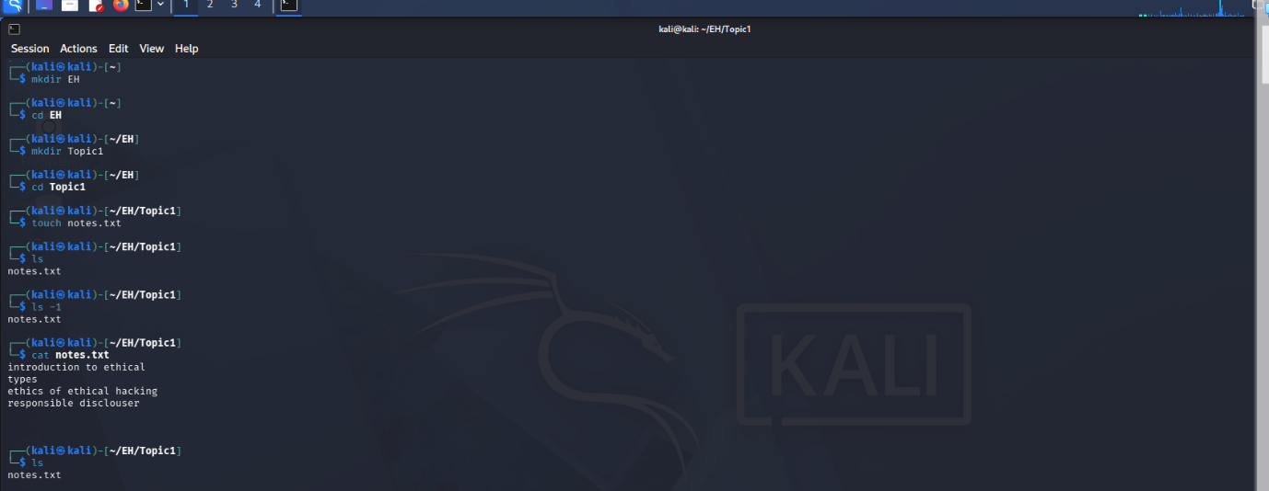

Result
Thus, the ls, cat, and mkdir commands were executed successfully in Kali Linux Operating System, and their results were displayed.

